CONCEPT NOTE
FOR THE DISCUSSION FORUM IN THE PLANNING NETWORK
ON TERRITORIAL RESILIENCE
(05.08.2023)
This concept note addresses the basic ideas to promote the discussion on the challenge of territorial resilience that will take place in the Planning Network for Development in Latin America and the Caribbean. For two months, an asynchronous forum will be held in Spanish and another asynchronous forum in English to reflect on the importance of building more resilient territories in the face of external shocks and risks associated with socio-natural disasters and climate change. At the end of the two months, a webinar will be organized, convening a conversation between experts. The call will be addressed both to the members of the Network and to professionals and public servants interested in this issue which occupies the public agendas of the vast majority of the countries in Latin America and the Caribbean.
The concept of resilience
ILPES has highlighted the importance of moving towards the construction of a resilient institutional framework in the face of adverse events that promotes the creation of public value, addressing resilience, understood as a polysemic concept, from the perspective of capacities. In this sense we understand the concept of resilience as the "capacity of a system, community, society exposed to a threat to resist, absorb, adapt and recover from its effects in a timely and effective manner which includes the preservation and restoration of its basic structures and functions".
This concept has multiple applications and approaches from different disciplines, such as psychology, ecology, disaster and threat management and multilevel management, and has generated a current applied to organizations or institutions. In this context, it is understood as the ability to anticipate potential threats, to deal effectively with unexpected events and to learn from them to produce a dynamic capacity aimed at facilitating an organizational change. From this process-centric perspective, resilience means responding effectively to adverse events not only after they occur, but also before and as they occur (Duchek, 2020).
When we refer to the concept of resilience of institutions, we refer to a group of renewed capacities that the State must exercise to anticipate, prepare, respond to and learn from the disruptive events it faces in public management. Some of these key capacities consist of participation mechanisms, foresight capacities, collaborative leadership, and strategic planning capacities. These capacities are not intended to be exhaustive or exclusive, but they are certainly a starting point.

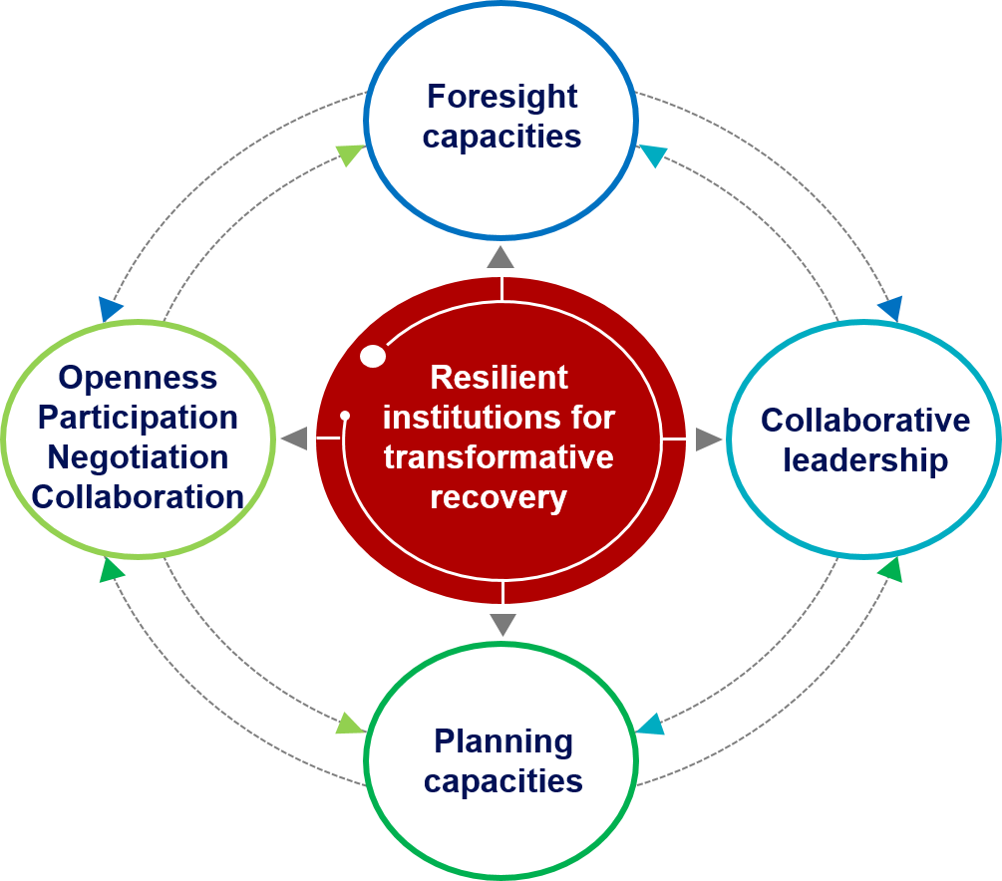

Source: "Resilient institutions for a transformative post-pandemic recovery in Latin America and the Caribbean: Inputs for discussion", ILPES.

Territorial resilience
In addition, ILPES in its more than 60-year history has had a special approach to the analysis of territorial dynamics as a decisive approach to achieve sustainable development. The 2030 Agenda for Sustainable Development also warns about the need to act in the territory to achieve the Sustainable Development Goals. Therefore, the territorial approach is an imperative in the analysis of resilience building.
From a territorial perspective, resilience can be defined as the capacity for preparation, response and positive adaptation evinced by some places as they confront adverse situations resulting from crises caused by external processes but reinforced by certain endogenous weaknesses that have made them especially vulnerable, so that they emerge strengthened by a domestic transformation strategy.
Territorial resilience is based on a holistic understanding of the territory, considering the natural, socioeconomic and cultural systems that form it. This involves the integration of different disciplines and sectors, as well as the active participation of the local community in the process of building resilience.
Strategies and practices that contribute to territorial resilience include sustainable management of natural resources, diversification of the local economy, strengthening of critical infrastructure, promotion of local culture and identity, citizen participation in decision-making and long-term strategic planning.
Territorial resilience is essential to ensure the sustainability and quality of life of local communities, as well as to ensure their ability to face and adapt to future challenges. It is therefore important to encourage awareness and understanding of territorial resilience in communities and promote its integration into territorial planning and management.
Building resilient territories requires both social and governmental capacities. Among the social capacities we can mention: trust, teamwork, legitimized leadership, shared norms and memory. Regarding government capacities, we can mention: reading the environment, critical thinking, identification of institutional strengths and weaknesses, negotiation, among others.
The construction of resilient territories faces multiple challenges, such as:
Complexity: since territories are complex systems that involve multiple variables and interconnected factors, which makes it difficult to understand and manage all the elements that influence the resilience of the territory.
Uncertainty: the future is uncertain, and communities and territories face a wide variety of unpredictable risks and threats, such as natural disasters, economic crises or climate change.
Limited resources: creating resilient territories often requires significant investment in terms of financial, human and technical resources, and the most vulnerable communities may not have the necessary resources to adequately address these challenges.
Coordination mechanisms: effective sectors and actors in each of the stages (preparation, response, reconstruction, learning) of the risk management cycle to socio-natural disasters.
Citizen involvement: through permanent mechanisms of participation.
The tension between the short, medium and long term in the planning and implementation of public policies: foresight and territorial resilience are two complementary approaches to planning and sustainable development of regions and territories. On the one hand, foresight focuses on the study of the possible futures of a region or territory through tools and methodologies that allow identifying changes and trends that may affect its development. In this way, foresight seeks to anticipate and prepare for possible future scenarios, which facilitates decision-making and the implementation of more effective public policies.
In this sense, foresight can be a useful tool to strengthen territorial resilience, since it allows identifying the possible risks and threats to which a region or territory may be exposed in the future, and developing strategies and policies that reduce their negative impact on the population and the territory.
For its part, territorial resilience can contribute to foresight by providing a more realistic and adaptive approach to future scenarios, as it fosters the capacity of local communities to adapt to changes and transformations in the territory, thus reducing uncertainty and improving the quality of future projections and estimates.
Therefore, foresight and territorial resilience are complementary approaches that can contribute significantly to the sustainable development of territories and regions, and strengthen their capacity to face future challenges and opportunities.
Addressing these challenges requires a holistic approach, including the integration of multiple disciplines and sectors, as well as the involvement of the local community in the planning and land management process. As ILPES argues, the construction of resilient territories is a dynamic process because challenges constantly arise that require new capacities to face them. That is why it is very important to build on the collective intelligence of the actors of the territory and memory so that these elements are incorporated into all stages of the cycle of planning, policies and the generation of solutions to public problems.
This is the general framework for initiating the discussion in the Planning Network, in which the following guiding questions are suggested:
- What are the main challenges in building more resilient territories? In rural territories? And in urban?
- What changes need to be made to achieve these new capacities at different levels of government?
- From the identification of new capacities in institutions at all levels of the State (collaborative leadership, planning capacities, foresight capacities, openness-participation-negotiation and collaboration) how are they built, maintained and articulated in the public administration?
• How can foresight capacities contribute to the construction of resilient territories?

The webinar will present the main ideas of the forum in both Spanish and English. The forum will have a simultaneous translation service.
In 2021, ILPES presented at the XVIII Meeting of the Regional Planning Council the document "Resilient institutions for a transformative post-pandemic recovery in Latin America and the Caribbean: Inputs for discussion".
Development Planning Notes "Disasters are not natural". No. 15/22

